RiverWare Standard Step Routing Parameter Creation Procedures for Reaches and Control Points

# Control Point Standard Step Routing Coefficients

In RiverWare the control points use routing coefficients that are linear coefficients used for routing flow from the upstream reservoirs (RiverWare Users Manual). The routing coefficients represent the percentage of released flow from upstream reservoirs that will reach this control point at each timestep.

Figure 1 and Table 1 show an example of inflow hydrograph and the corresponding routing coefficients. The routing coefficients need to add up to exactly 1.0.

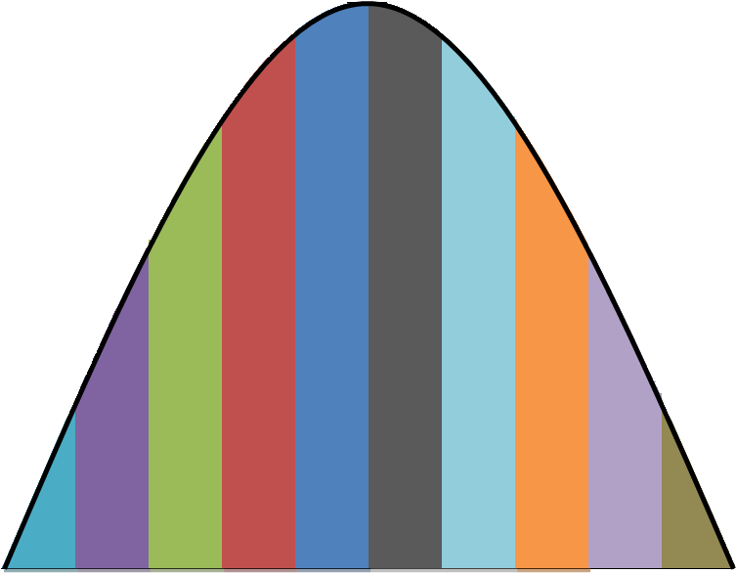

**10**

**9**

**8**

**7**

**6**

**5**

**4**

**3**

**2**

**1**

Figure . Inflow hydrograph to a control point, with the colored area below the curve representing the percentage of flow correlating to that section.

Table . Routing coefficients from inflow hydrograph shown in Figure 1.

|  |  |
| --- | --- |
|  | Hulah |
|  | Routing Coefficient |
| 1 | 0.02 |
| 2 | 0.05 |
| 3 | 0.08 |
| 4 | 0.15 |
| 5 | 0.2 |
| 6 | 0.2 |
| 7 | 0.15 |
| 8 | 0.08 |
| 9 | 0.05 |
| 10 | 0.02 |

For each reservoir upstream of a control point near channel capacity releases are made for a six hour period. These releases are routed through reaches to the control points using HEC-1 VANT model, which was modified from the VANB model. It includes routing from KAW, PENS, and HUDS, which were not part of the VANB model. The releases from each reservoir must be run separately to determine the corresponding routing coefficients for only this reservoir. The resulting flows are stored in a Dssfile, and the routing coefficients can be calculated using the StandardStep_Routing script.

In the StandardStep_Routing script the routing coefficients are calculated as the sum of the flow for a 6-hour time period divided by the sum of the total flow through the control point, and is summarized in the following equation

$$Routing coefficient= \frac{\sum^{6-hr period }{flow}}{\sum{Total flow}}$$

Since, the routing coefficients have to add up to exactly 1.0, there is a small error introduced by setting the precision. This error is then added to the maximum routing coefficients. The error is very small and will not significantly change the results. The resulting routing coefficients are placed in a Dssfile with the same pathnames as the routing reach, except the f part was changed from CALC to REACHSTEP.

# Routing Reach Lag Coefficients

The routing reach lag coefficients are similar to the routing coefficients in that they use the standard step routing, but this time these lag coefficients are for flow through the reach, instead of from an upstream reservoir.

In order to calculate the lag coefficients a flow near channel capacity is input for 6-hours at the upstream end of the reach. At the downstream end of the reach the resulting hydrograph is used with the method described above to calculate the lag coefficients. The StandardStep_ReachRouting script is used to calculate the lag coefficients and save the results to a dssfile.